Project Design Phase-II
Data Flow Diagram & User Stories
Date
Team ID
Project Name | Incident Lifecycle Automation in ServiceNow
Maximum Marks | 4 Marks

Data Flow Diagrams:
A Data Flow Diagram (DFD) is a traditional visual representation of the information flows within a system. For this project, the DFD shows how incident information enters ServiceNow, how the Incident Management process uses and updates the information, and how related records such as Knowledge, Task SLAs, child incidents, and emergency changes are connected.

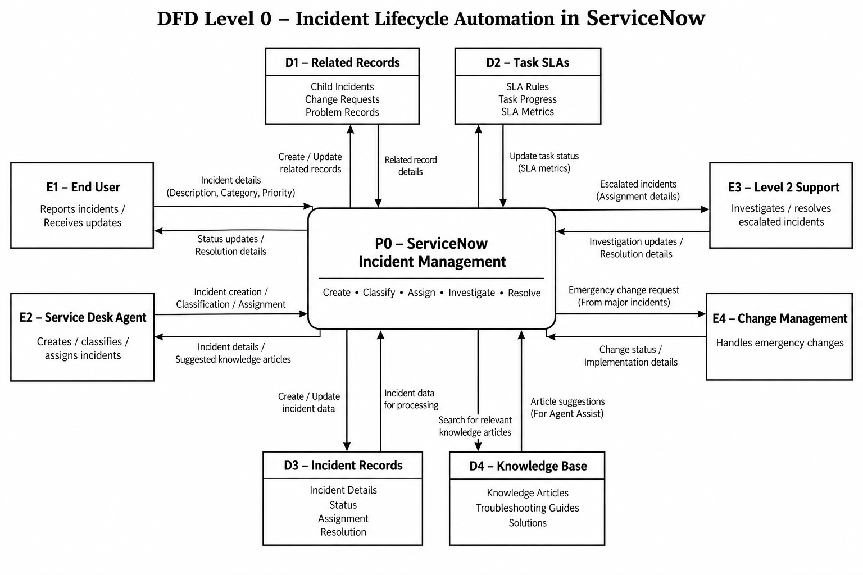

The Level 0 DFD represents End Users and Service Desk Agents as incident-information sources, Level 2 Support as the investigation and resolution stakeholder, and Change Management as the stakeholder for emergency changes. ServiceNow Incident Management acts as the central process and maintains incident, knowledge, related-record, and SLA information.

User Stories
The following user stories are specific to the Incident Lifecycle Automation in ServiceNow project and use the template's required columns.
User Type | Functional Requirement (Epic) | User Story Number | User Story / Task | Acceptance criteria | Priority | Release
End User | Incident Management | USN-1 | As an end user, I can report an IT issue so that it can be tracked as an incident in ServiceNow. | Incident record can be created with caller and short description. | High | Sprint-1
Service Desk Agent | Incident Management | USN-2 | As a Service Desk Agent, I can create an incident in Service Operations Workspace. | Incident record is saved with required initial details. | High | Sprint-1
Service Desk Agent | Incident Classification | USN-3 | As a Service Desk Agent, I can classify an incident using category and subcategory. | Category and subcategory are recorded on the incident. | High | Sprint-1
Service Desk Agent | Incident Classification | USN-4 | As a Service Desk Agent, I can set urgency, service, service offering, and configuration item. | The selected incident details are visible in the Details tab. | High | Sprint-1
Service Desk Agent | Knowledge Integration | USN-5 | As a Service Desk Agent, I can use Agent Assist to find relevant Knowledge articles. | Relevant Knowledge articles can be viewed from Agent Assist. | High | Sprint-1
Service Desk Agent | Knowledge Integration | USN-6 | As a Service Desk Agent, I can attach a relevant Knowledge article to an incident. | The selected article is attached and visible in the incident activity/related information. | Medium | Sprint-2
Service Desk Agent | Assignment & Escalation | USN-7 | As a Service Desk Agent, I can assign or reassign an incident to the appropriate support group. | Assignment group is updated and the incident is available to the selected team. | High | Sprint-2
Level 2 Support | Level 2 Investigation | USN-8 | As a Level 2 technician, I can access the incident details, Knowledge information, and SLA information needed for investigation. | Assigned Level 2 user can view incident details, Knowledge support, and Task SLAs. | High | Sprint-2
Level 2 Support | Level 2 Investigation | USN-9 | As a Level 2 technician, I can document investigation activities in the incident. | Work notes and activity updates are saved against the incident. | Medium | Sprint-2
Change Management Team | Emergency Change | USN-10 | As a support team member, I can initiate the required emergency change activity from the incident. | The incident can be placed On Hold with the appropriate change-related reason and related change activity is traceable. | High | Sprint-3
Service Desk Agent | Child Incident Management | USN-11 | As a Service Desk Agent, I can create a child incident for a related user issue. | Child incident is created and listed under the parent incident's Related Records. | Medium | Sprint-3
Level 2 Support | Incident Resolution | USN-12 | As a Level 2 technician, I can record the probable cause of an incident. | Probable cause is saved against the incident. | High | Sprint-3
Level 2 Support | Incident Resolution | USN-13 | As a Level 2 technician, I can record the resolution code and resolution notes and resolve the incident. | Resolution code and notes are saved and the incident state changes to Resolved. | High | Sprint-3
Service Desk Agent | Knowledge Creation | USN-14 | As a Service Desk Agent, I can create a Knowledge article from a resolved incident. | Knowledge article is created in the selected Knowledge Base and linked to the parent record. | Medium | Sprint-4
ServiceNow Administrator | SLA & Related Records | USN-15 | As a ServiceNow Administrator, I can verify SLA information and related records for an incident. | Task SLAs and related records are visible and traceable. | High | Sprint-4
ServiceNow Administrator | Final Validation | USN-16 | As a ServiceNow Administrator, I can validate the complete incident lifecycle from creation through resolution and knowledge creation. | Parent incident, child incident, change activity, Knowledge article, and SLA information can be verified. | High | Sprint-4
Service Desk Agent | Testing & Deployment Validation | USN-17 | As a Service Desk Agent, I can validate the end-to-end incident workflow before deployment. | Incident lifecycle, escalation, change integration, Knowledge creation, child incidents, SLA tracking, and multi-team collaboration are validated. | High | Sprint-4

Consistency Note: User story numbering is maintained sequentially from USN-1 to USN-17. Release allocation follows the project lifecycle from incident creation and classification through knowledge integration, escalation, resolution, knowledge creation, and final validation.

